Marketing 101: The Engine of Growth 🚀

Marketing 101: The Engine of Growth 🚀
Welcome to the first step in taking control of your business. Before we touch a single ad, you need to understand what marketing truly is. For a loan officer, marketing isn't just about getting your name out there.

Marketing is making people want what you sell.
Sales is making them buy it.

It’s the answer to the question, "How do I get my next client?" And more importantly, "How do I get my next 10, 50, or 100 clients?" Most loan officers rely on hope — the hope that a referral partner sends them a deal, or that someone they know needs a loan. Hope is not a strategy. This bootcamp is about trading hope for a system.

This lesson will teach you the foundational concepts of that system, why it's the fastest way to scale your production, and how to think about the different ways to attract clients.

The Paid Acquisition Engine ⚙️
Imagine a machine. For every $1 you put into it, $5 comes out.

If you had a machine like that, how many dollars would you put into it? As many as you could, right?

That machine is a paid acquisition system.

It's a predictable, measurable, and scalable engine for generating leads and closing loans. This is the fundamental difference between running a practice and running a business.

- A practice relies on the loan officer's personal effort, charisma, and network. When you stop, the business stops. It's unpredictable and difficult to scale.
- A business runs on systems. It has a marketing engine that generates leads consistently, whether you are networking or not. This is what allows for true scale.

Key Takeaway: Our goal is to stop hunting for individual deals and start building a machine that brings deals to us.

What an Ad Really Is 🤔
The True Goal of an Ad: Get the Click
Most people think the goal of an ad is to get somebody to buy something. That's not true. They think running ads means getting a flood of ready-to-go, pre-sold, pre-educated prospects who are just waiting to hand over their documents. That's not how this works.

The ad has one job, and one job only: get the right person to click.

Think of your entire sales process like a funnel, where each stage has one specific job:

- The Ad's Job: Get the click.
- The Landing Page's Job: Get the lead information.
- The First Call's Job: Build trust and book the appointment.
- The Consultation's Job: Educate and close the loan.

If you try to sell at the ad stage, you'll scare everyone away. The ad's only job is to be so compelling and speak so directly to a specific problem that the right person can't help but click to learn more.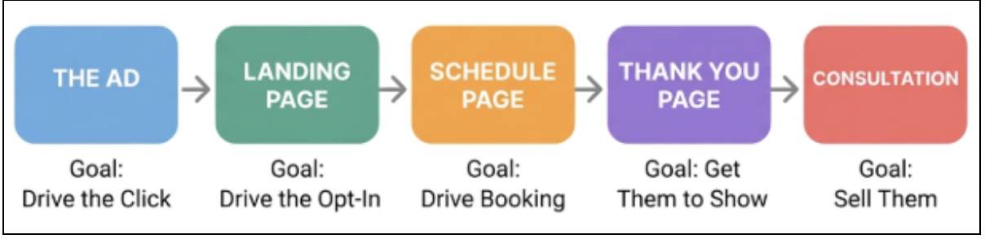

What is a "Qualified Lead"?
Most people have a completely skewed perception of what a qualified lead is. They think a qualified lead should be warm, ready to buy, and easy to close. That's a referral lead, not a paid ad lead.

A qualified lead from paid advertising is someone who:

- Has the problem you can solve (e.g., is a homeowner over 62 struggling with cash flow).
- Has the means to solve it (e.g., has sufficient equity in their home).

That’s it. That doesn't mean they'll be an easy sale. It doesn't mean they know you, like you, or trust you. It just means they're qualified to be helped by you.

You have to be okay with the fact that when you run paid ads, these people have never heard of you before. The probability of them coming in hot and ready to buy is very low. This is why the rest of your system (your follow-up, your nurturing, your sales process) is so critical.

Referrals vs. Paid Ads ⚖️
The Problem with a Referral-Only Business
Most businesses rely entirely on word of mouth and referrals. The problem? Referrals are incredibly inconsistent. You never know how many clients you're going to get month-to-month. It's a revenue roller coaster.

Yes, referral leads are often higher quality and easier to close. But you can't control the volume. You can't decide to get 10 more referrals next month. You're completely dependent on other people.

With paid ads, even though the leads are colder and harder to sell, you CAN control the scale. You can put a dollar in and get five dollars out because it all comes down to simple math: the number of leads you need, your booking rate, your show rate, and your close rate. That's it. You are in control of the machine.
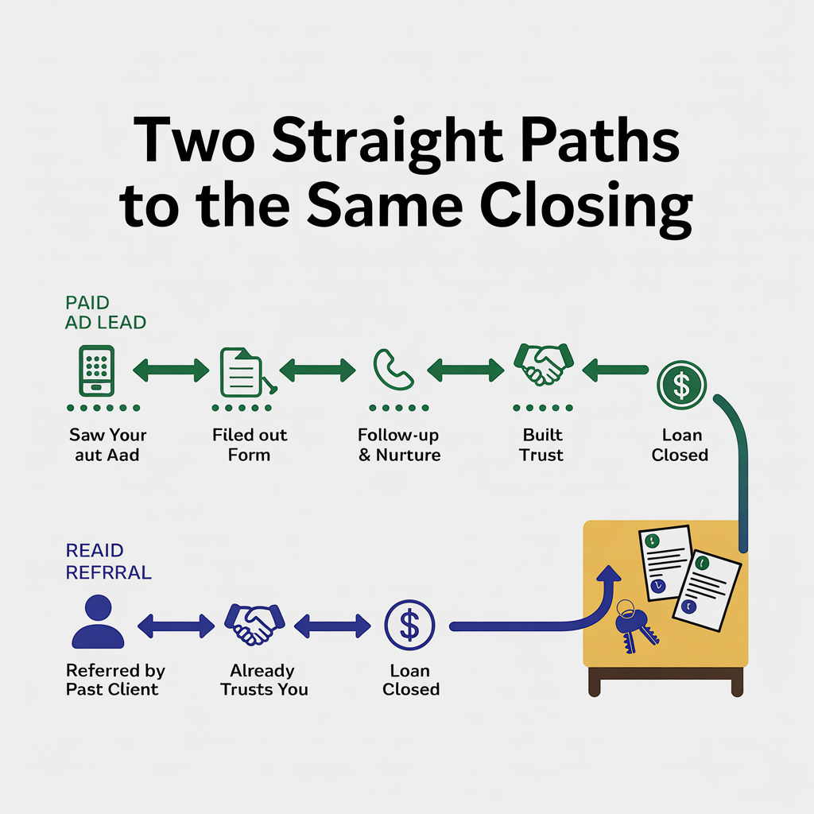

Channel Comparison
Lead Channel | Strengths | Weaknesses | The Verdict
Paid Media (Facebook, Google) | Scalable, predictable, data-rich, fast. You are in complete control of the volume. | Upfront cost, requires expertise, leads are "cold." | The Primary Engine for Growth. The only channel that is truly scalable on demand.
Referral Partners | High trust, leads are "warm" and easier to close. | Inconsistent, slow to build, unpredictable. You are not in control of the lead flow. | A valuable supplement, but never build your business on it.
Direct Mail | Can generate high volume of exclusive, inbound calls. | Very few KPIs to track, declining open rates, hard to test and optimize quickly. | An older model. Can work, but lacks the data and speed of digital channels.
Organic Social Media | Builds brand and authority over time, no direct ad cost. | Inconsistent, incredibly slow to scale, requires significant time investment for unpredictable results. | Good for long-term brand building, not for predictable lead generation.

The Core Difference: Trust vs. Intent
A lead from a trusted financial advisor is fundamentally different from a lead you generate yourself from a Facebook ad. Treating them the same is a recipe for failure.

- The Referral Lead: Comes with pre-built trust. Your job is to facilitate the transaction.
- The Paid Ad Lead: Comes with zero trust. They have intent to solve a problem, but they don't know you. Your job is to build trust from scratch through education and empathy.

Warning: The habits that make you successful with referral leads will make you fail with paid ad leads. You cannot rush the process. You must embrace the role of an educator who builds trust through empathy and transparency.

